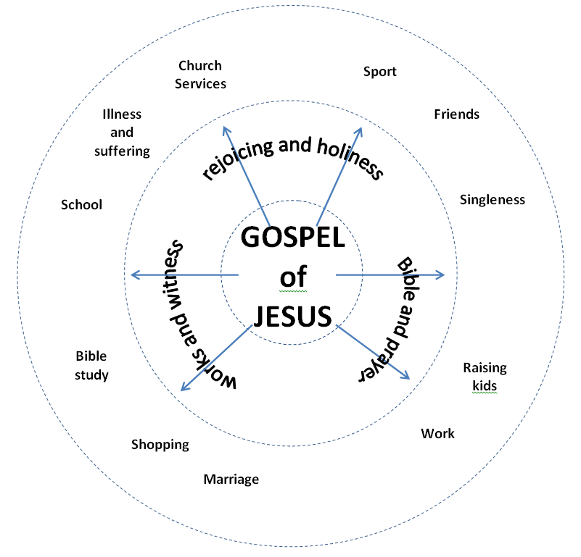

Who are we anyway?
We are God’s Gospel people!

The Gospel of Jesus is at the centre of our individual and church life.
Through His death Jesus saves us from our sins,
and through His resurrection He is declared Lord of the universe.

If we truly believe this:
we will respond with rejoicing and holiness because Jesus is our Saviour and Lord;
we will maintain our relationship with God through the Bible and prayer;
we will accept the responsibility to promote the Gospel by
our good works and by our words of witness to Jesus.

Your purpose for living can be summed up by these 6 words!
This is what God has left you on earth to do and to be.
This is what brings glory to Him.

Our purpose as a church is to encourage each other to live them out.

SO… spin the wheel to line up each word with a life activity or situation
and prayerfully think through how it applies to you.

Who are we anyway?
We are God’s Gospel people!

The Gospel of Jesus is at the centre of our individual and church life.
Through His death Jesus saves us from our sins,
and through His resurrection He is declared Lord of the universe.

If we truly believe this:
we will respond with rejoicing and holiness because Jesus is our Saviour and Lord;
we will maintain our relationship with God through the Bible and prayer;
we will accept the responsibility to promote the Gospel by
our good works and by our words of witness to Jesus.

Your purpose for living can be summed up by these 6 words!
This is what God has left you on earth to do and to be.
This is what brings glory to Him.

Our purpose as a church is to encourage each other to live them out.

SO… spin the wheel to line up each word with a life activity or situation
and prayerfully think through how it applies to you.

